VSCode and C++

# Contents

Installing C++ for VSCode

Running C++ scripts without CodeRunner

Debugging C++ in VSCode

# If stuck, see:

<https://code.visualstudio.com/docs/cpp/config-mingw>

<https://www.youtube.com/watch?v=DIw02CaEusY>

# Installing C++ for VSCode:

More info: <https://code.visualstudio.com/docs/cpp/config-mingw>

Steps:

1. Download the C++ VSCode extension



1. Install MinGW:
   1. <https://sourceforge.net/projects/mingw-w64/files/Toolchains%20targetting%20Win32/Personal%20Builds/mingw-builds/installer/mingw-w64-install.exe/download>
   2. Take note of your installation path (needs to be added to path)

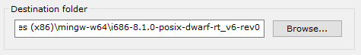

1. Add the “bin” directory of your MinGW installation to path
   1. Search path in windows

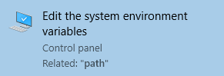

* 1. In the “Advanced” tab, click the “Environment Variables” button

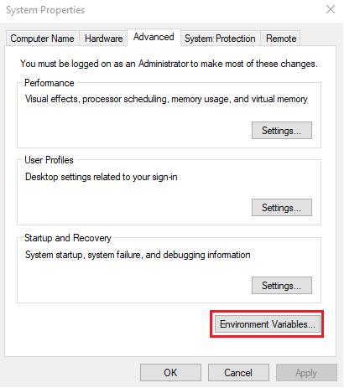

* 1. Under “System variables” edit “Path”

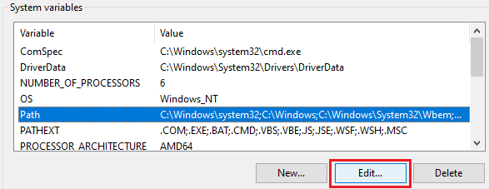

* 1. Add the “bin” folder of your MinGW installation to path and click OK

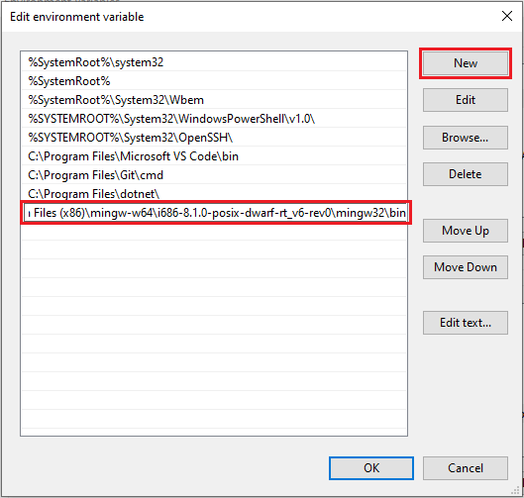

1. Check your MigGW installation
   1. Run g++ --version in command prompt

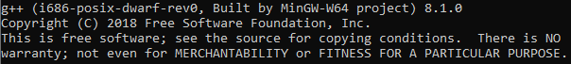

* 1. Run gdb --version in command prompt

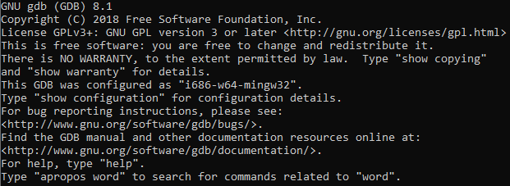

1. If already open, restart VSCode. Open a folder in VSCode and make a HelloWorld.cpp script using the following:

(A copy of this script can be found in the “more info” link at the top)

#include <iostream>

#include <vector>

#include <string>

using namespace std;

int main()

{

vector<string> msg {"Hello", "C++", "World", "from", "VS Code", "and the C++ extension!"};

for (const string& word : msg)

{

cout << word << " ";

}

cout << endl;

}

1. Download the Code Runner extension



1. Click the Code Runner run button

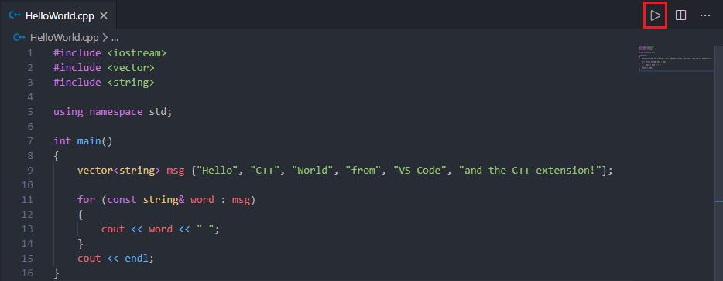

1. Celebrate the fact that Code Runner has optimized the tedious C++ code compilation and running process

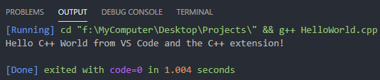

1. However, a few more steps are required to run more complex OOP code with multiple .cpp files. Click the gear symbol on the code runner extension and select “Extension Settings”

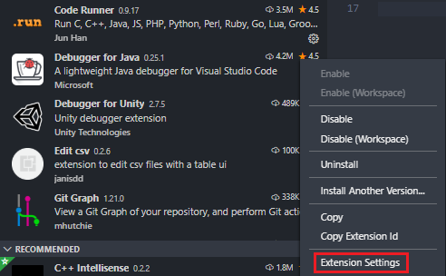

1. Under Executor Map, select “Edit in settings.json”

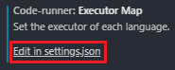

1. Copy and paste the following into the JSON file as shown and save:
   1. These lines tell CodeRunner to compile all .cpp files rather than just the active file.

"code-runner.executorMap": {

"cpp": "cd $dir && g++ -o $fileNameWithoutExt *.cpp && $dir$fileNameWithoutExt"

}

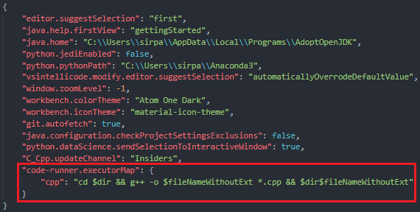

1. Hope that C++ is now fully functional and that there will be no more future additions to this tutorial. The above setup does not need to be repeated. It will now work for all future projects on your device. CodeRunner is a useful, low effort way to run C++ in VSCode. However, using this method, you will not be able to debug. To gain full C++ utility in VSCode, I suggest you see the following sections.

# Running C++ scripts without CodeRunner

Let’s assume you don’t like being able to compile and run code at the press of a button. What do you do to run C++ files in VSCode? There are more steps. However, after setup, the process for compiling and running code is quick.

1. Important: Ensure your VSCode directory is set to the location of your .cpp files
2. Create a tasks.json file for building your code **(1 time setup per project)**
   1. With a .cpp file open, under “Terminal” select “Configure Default Build Task…”

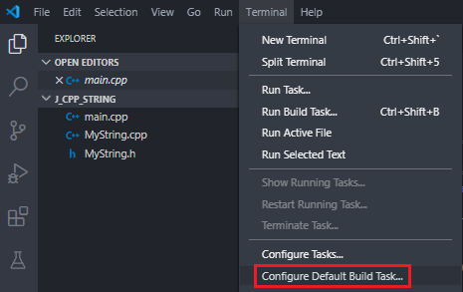

* 1. Select “C/C++: g++.exe build active file”. This creates a tasks.json file. You should see it in your directory.

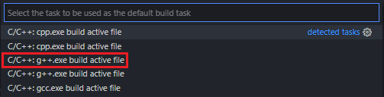

* 1. Change the “${file}” entry under “args” to "${workspaceFolder}\\*.cpp" and save. This tells VSCode to compile all C++ files in the directory rather than just the active file.

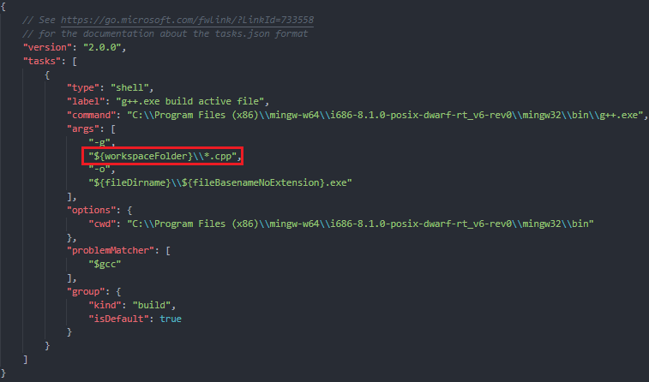

* + 1. You can now compile your code using “Ctrl+Shift+B” or selecting “Run Build Task”

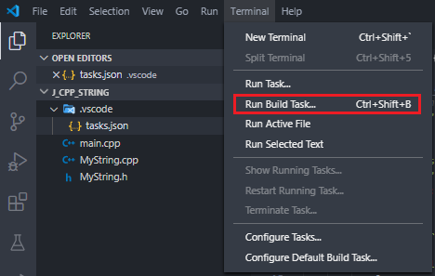

1. Compile and run your code
   1. Press “Ctrl+Shift+B” to compile your code. A “Task – g++.exe build” terminal should launch. You should also see an executable file created in your directory.

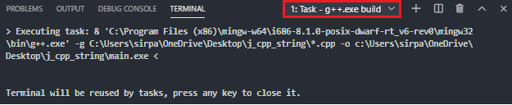 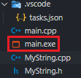

* 1. Press “+” to open a new terminal and run your executable file using .\[filename].exe

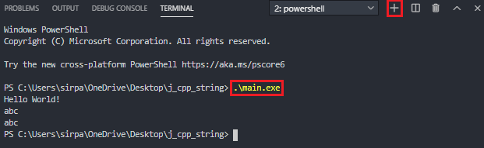

# Debugging C++ in VSCode

1. Build a tasks.json file as described in steps 1 and 2 of Running C++ Scripts Without CodeRunner section
2. Create a launch.json file to configure the debugger **(1 time setup per project)**
   1. Click on “Run” (or “Debug” if using an old version of VSCode) and select “Add Configuration”

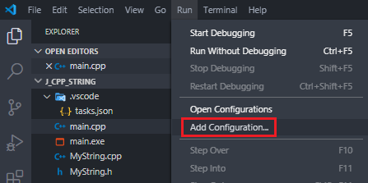

* 1. Select “C++ (GDB/LLDB).

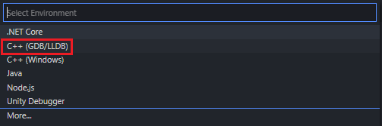

* 1. Select “g++.exe – Build and debug active file”.
     1. This will create a “launch.json” file. You should see it in your directory.

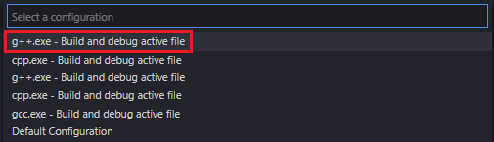

* + 1. Note that this option automatically sets the paths to your executable file and your mingw32 directory.

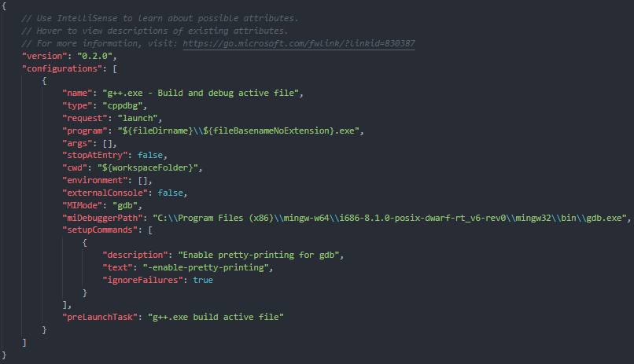

1. Debug your file
   1. Add breakpoints to your code. Then, on the debug tab, ensure your build is set to “g++.exe – Build and debug active file” and press the play button (or F5).
      1. Alternatively, you can right click the script and select “Build and Debug Active File” then select “g++.exe – Build and debug active file” as your compiler.

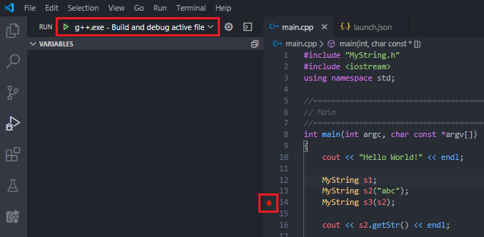

* 1. Congratulations, you are now debugging your file.

